# How to assign MFA to the user from the root user?

1. Login from the root user
2. Then select particular user from the list
3. In Security credentials click on Assign MFA device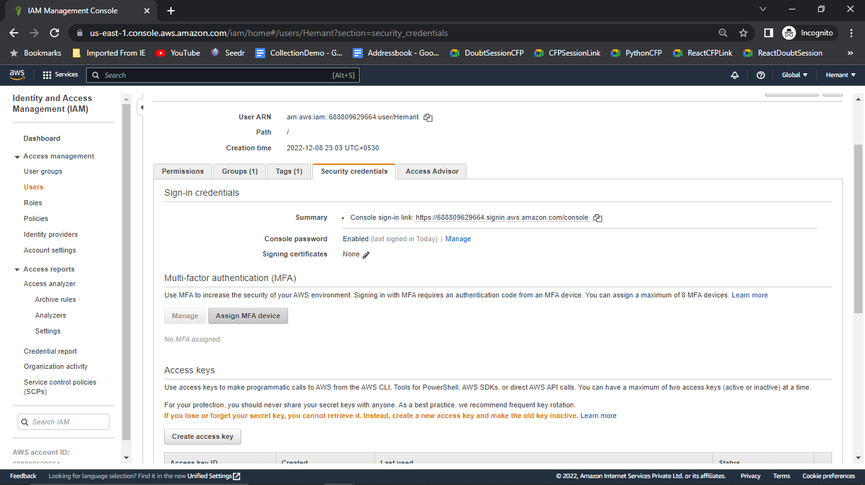
4. Give a Name and select Virtual MFA Device and for that we have to download google authenticator app from the app store in mobile 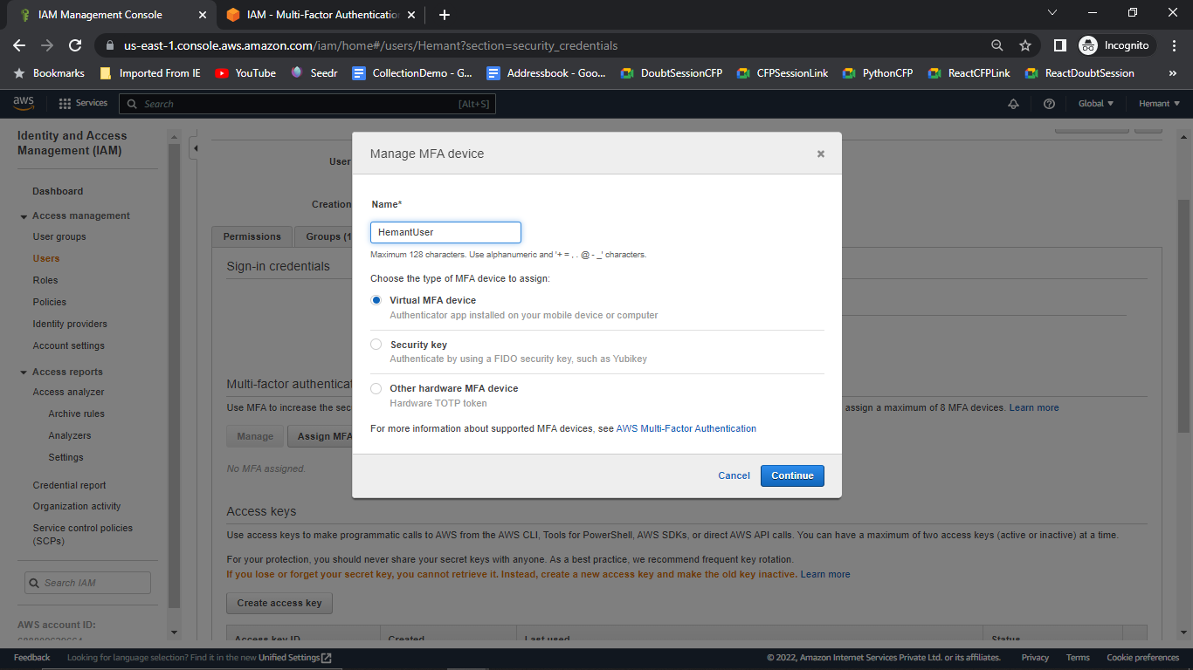
5. After scanning the code we will get otp which is validated for the 30 sec only after successful completion one dialog box appears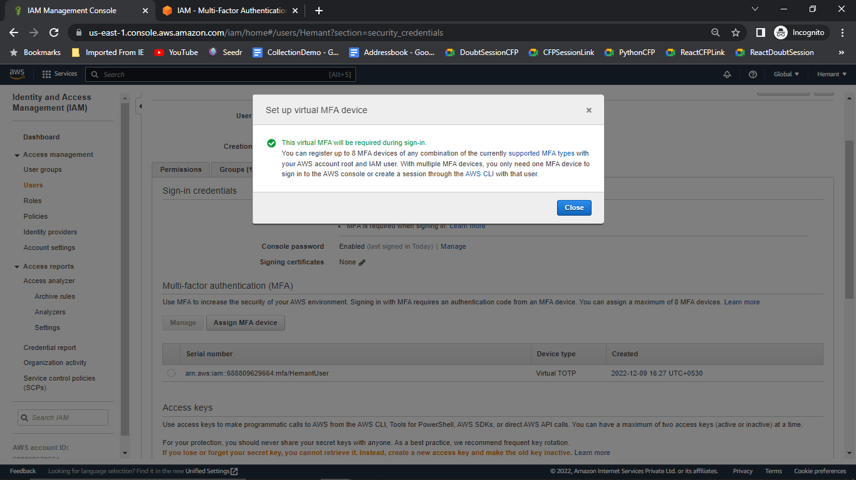
6. Now we have to login again from that user but this time it’ll ask for the MFA code which is again available in the authenticator app..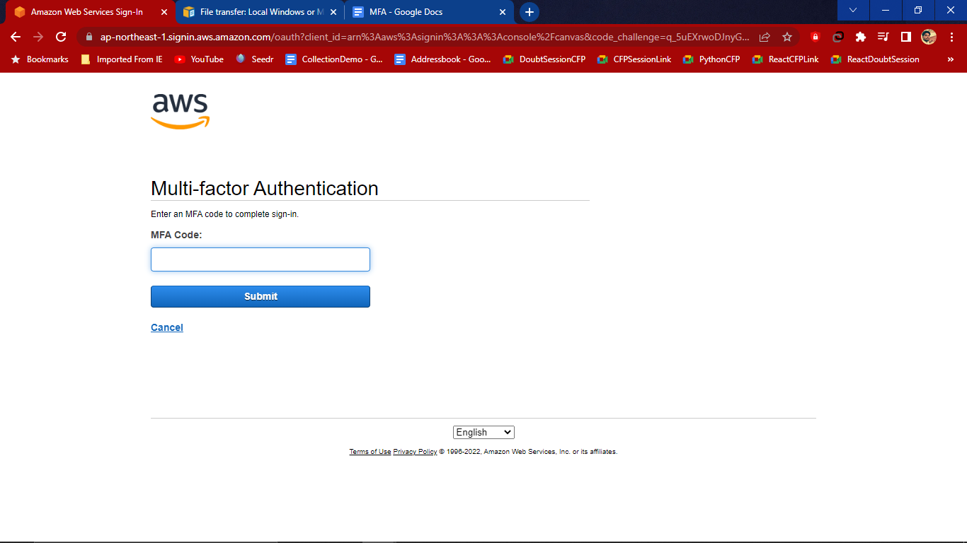
7. After submit dashboard appear with one instance running